Neural Network Assignment -5
Name = Hema Rajput
Roll no = 24UADS1062

5.WAP to train and evaluate a convolutional neural network using Keras Library to classify MNIST fashion dataset. Demonstrate the effect of filter size, regularization, batch size and optimization algorithm on model performance.

import numpy as np
import tensorflow as tf
import matplotlib.pyplot as plt
from tensorflow.keras.datasets import fashion_mnist
from tensorflow.keras.models import Sequential
from tensorflow.keras.layers import Input, Conv2D, MaxPooling2D, Flatten, Dense, Dropout
from tensorflow.keras.regularizers import l2

# Load dataset
(x_train, y_train), (x_test, y_test) = fashion_mnist.load_data()

# Normalize data
x_train = x_train / 255.0
x_test = x_test / 255.0

# Reshape data for CNN
x_train = x_train.reshape(-1,28,28,1)
x_test = x_test.reshape(-1,28,28,1)

print("Training Data Shape:", x_train.shape)
print("Testing Data Shape:", x_test.shape)

# Function to build CNN model
def create_model(filter_size, optimizer_name):

model = Sequential([

Input(shape=(28,28,1)),

Conv2D(32, (filter_size,filter_size), activation='relu'),
MaxPooling2D((2,2)),

Conv2D(64, (filter_size,filter_size), activation='relu'),
MaxPooling2D((2,2)),

Flatten(),

Dense(128, activation='relu', kernel_regularizer=l2(0.001)),
Dropout(0.5),

Dense(10, activation='softmax')
])

model.compile(
optimizer=optimizer_name,
loss='sparse_categorical_crossentropy',
metrics=['accuracy']
)

return model

# Experiment Parameters
filter_sizes = [3,5]
batch_sizes = [32,64]
optimizers = ['adam','sgd']

# Run experiments
for f in filter_sizes:
for b in batch_sizes:
for opt in optimizers:

print("\n-----------------------------------")
print("Filter Size:",f," Batch Size:",b," Optimizer:",opt)
print("-----------------------------------")

model = create_model(f,opt)

history = model.fit(
x_train,
y_train,
epochs=5,
batch_size=b,
validation_split=0.2,
verbose=1
)

loss, accuracy = model.evaluate(x_test,y_test)

print("Test Accuracy:",accuracy)

# =========================
# Graph 1 : LOSS vs EPOCH
# =========================

plt.figure()

plt.plot(history.history['loss'], label="Training Loss")
plt.plot(history.history['val_loss'], label="Validation Loss")

plt.title(f"Loss Graph (Filter {f}, Batch {b}, Opt {opt})")
plt.xlabel("Epoch")
plt.ylabel("Loss")

plt.legend()
plt.show()

# =========================
# Graph 2 : ACCURACY vs EPOCH
# =========================

plt.figure()

plt.plot(history.history['accuracy'], label="Training Accuracy")
plt.plot(history.history['val_accuracy'], label="Validation Accuracy")

plt.title(f"Accuracy Graph (Filter {f}, Batch {b}, Opt {opt})")
plt.xlabel("Epoch")
plt.ylabel("Accuracy")

plt.legend()
plt.show()

1.Output
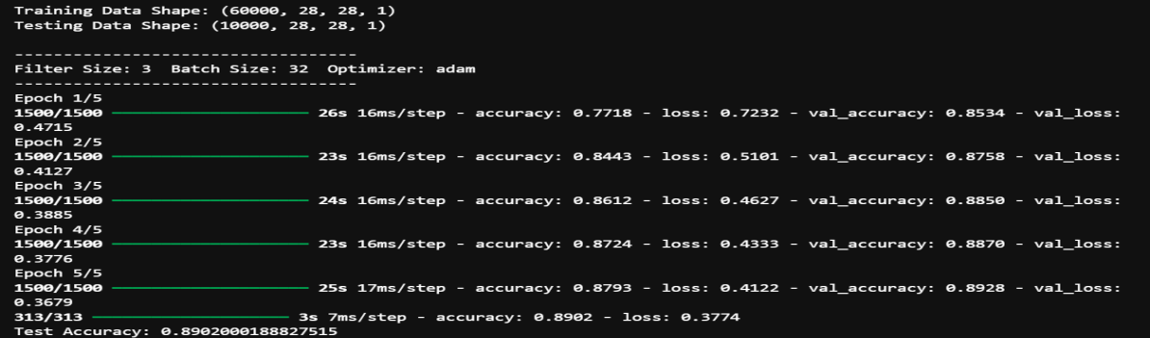
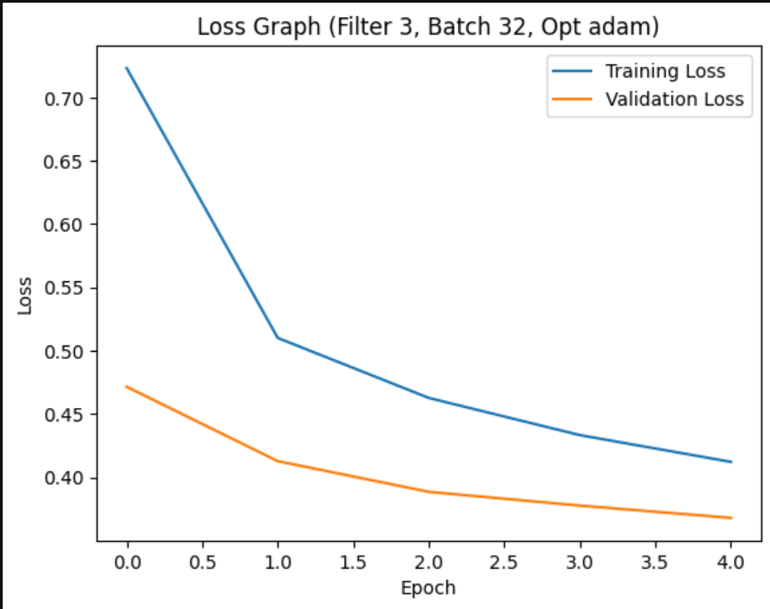

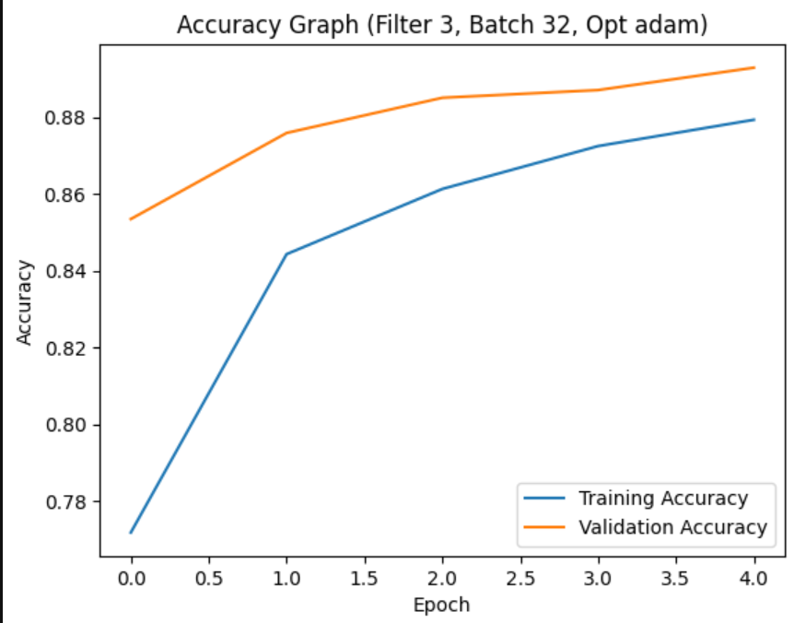
2.output
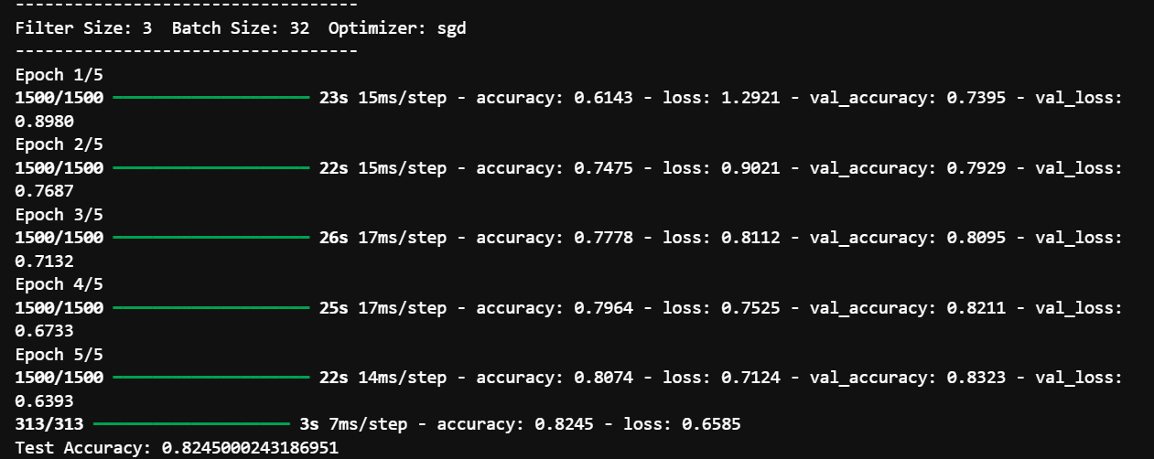

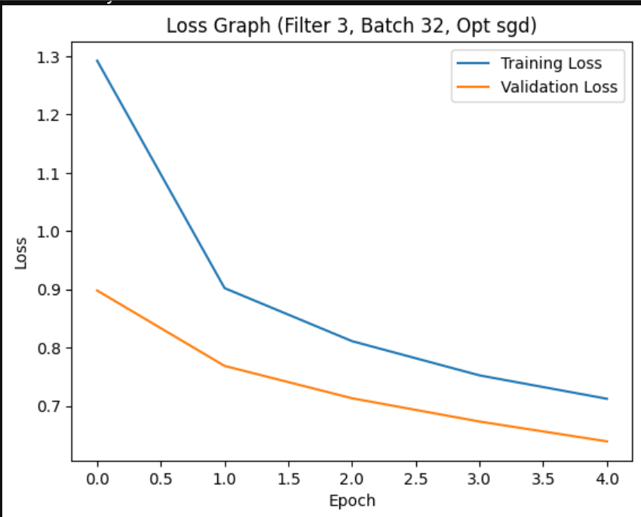
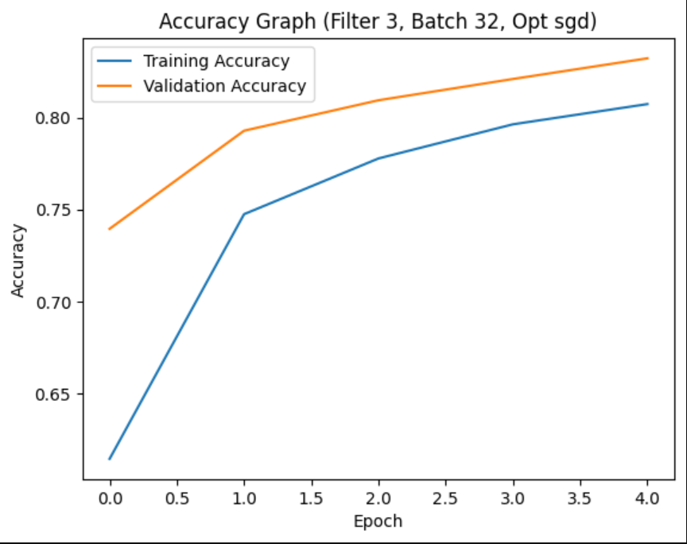
3.output
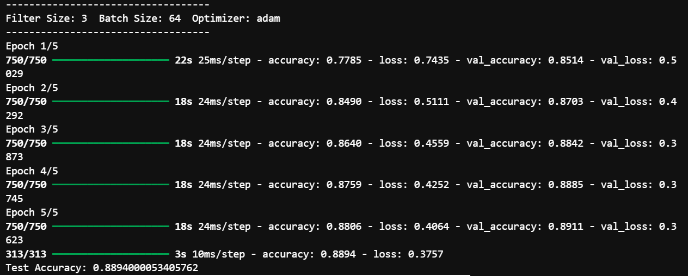
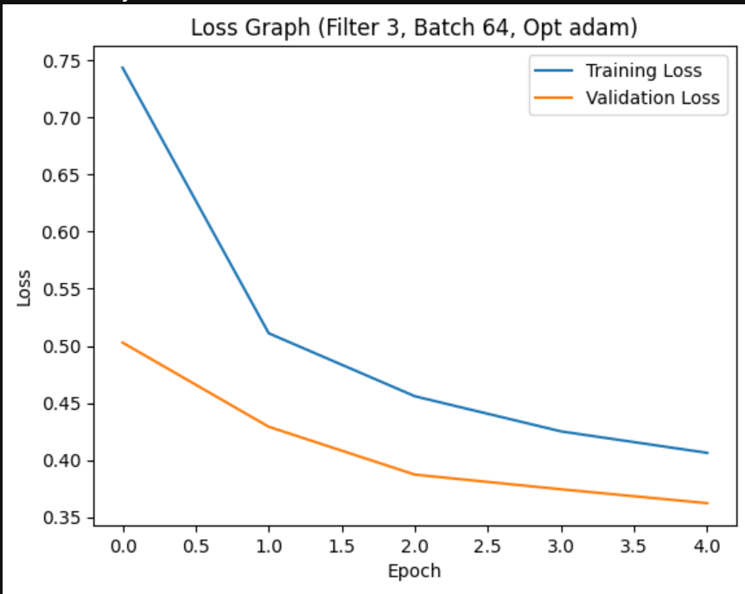
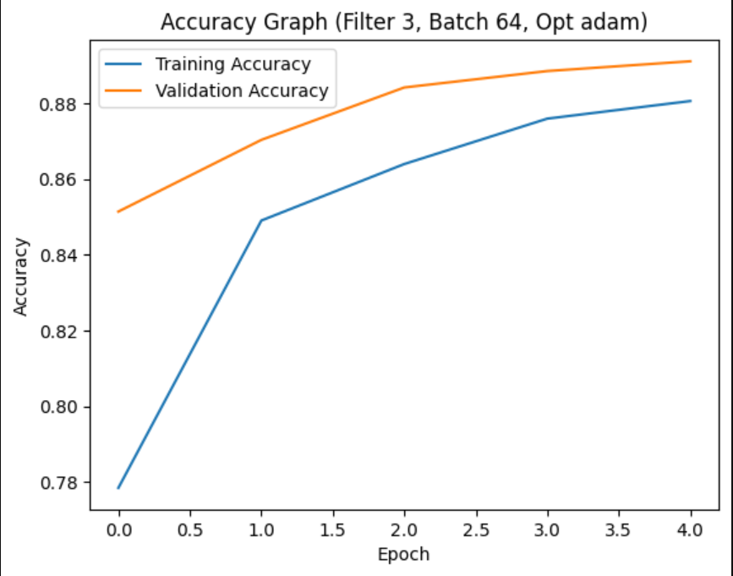
4.output
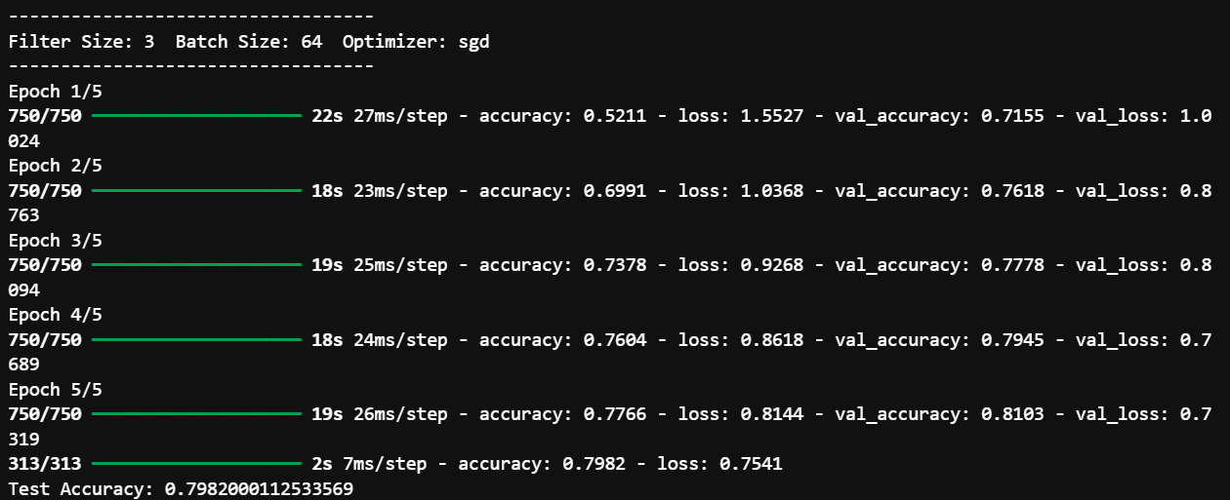
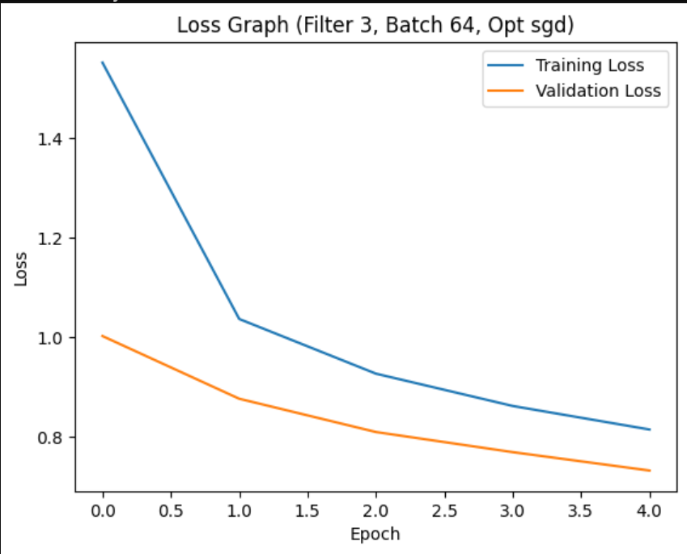
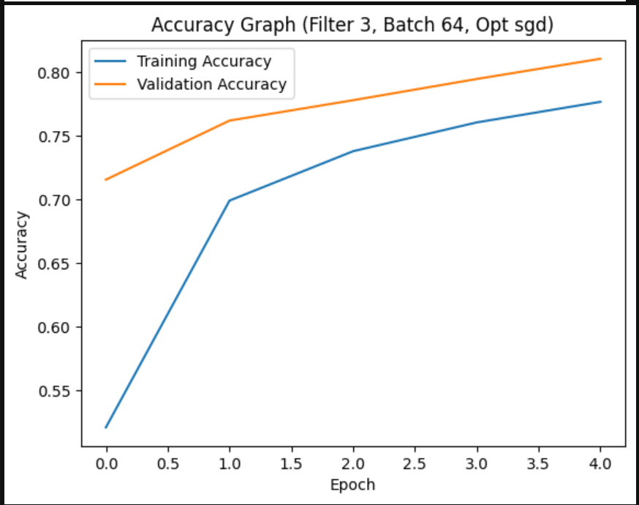
5.output
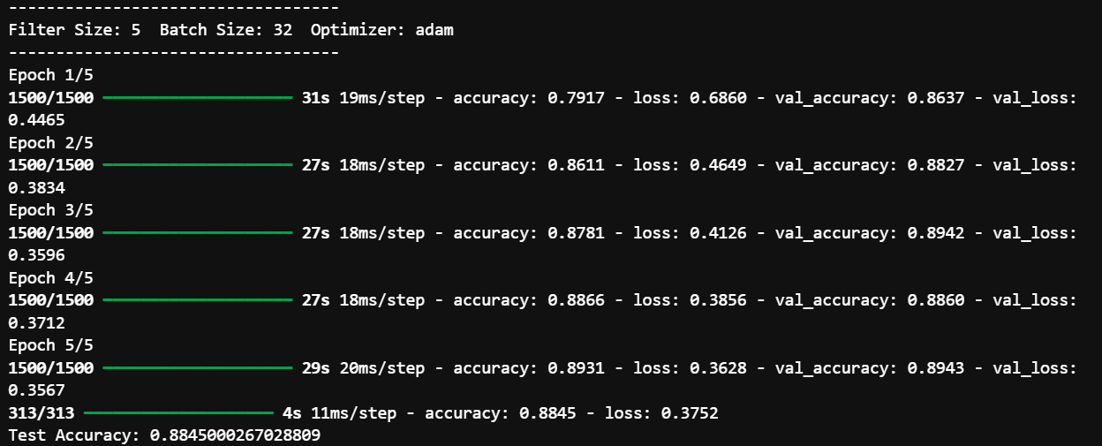
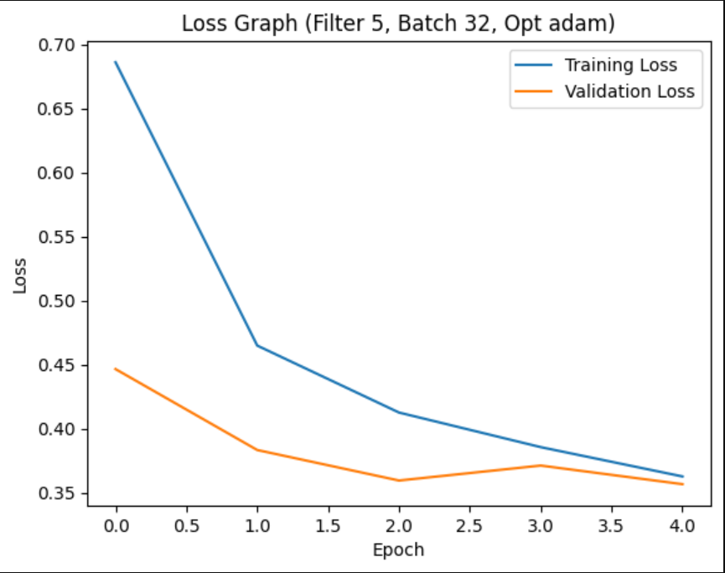
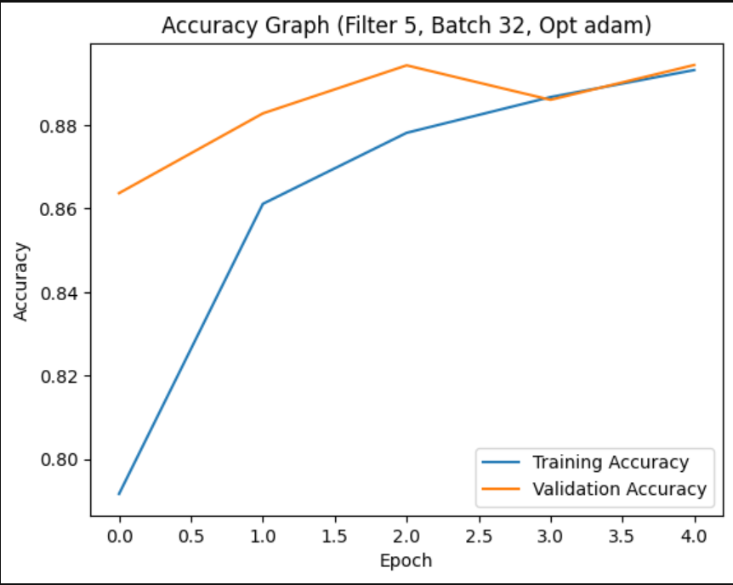
6.output
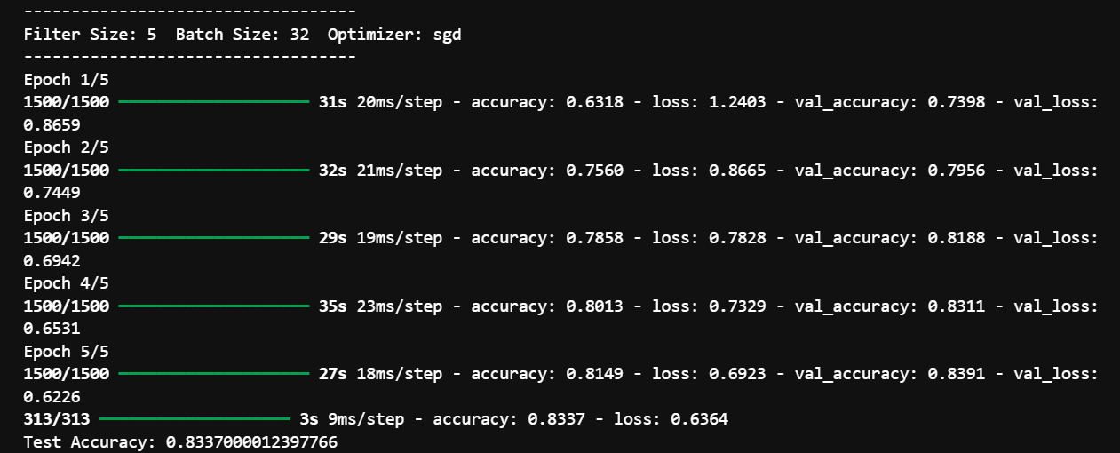
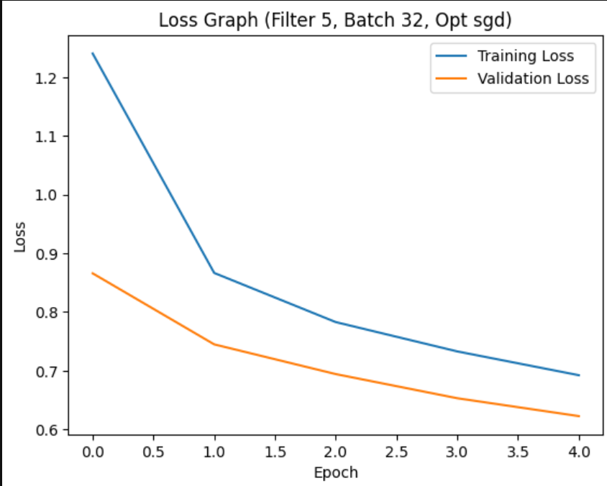
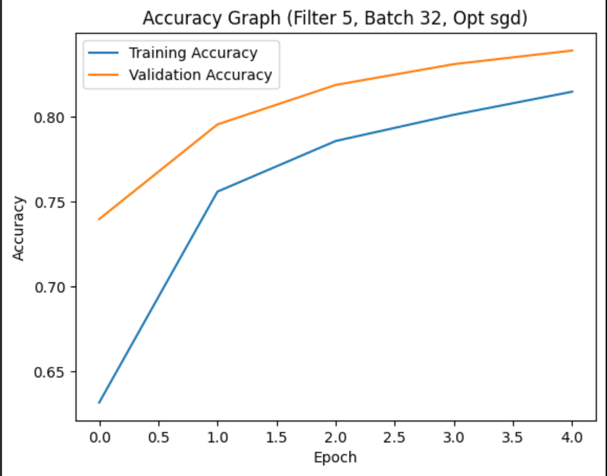
7.output
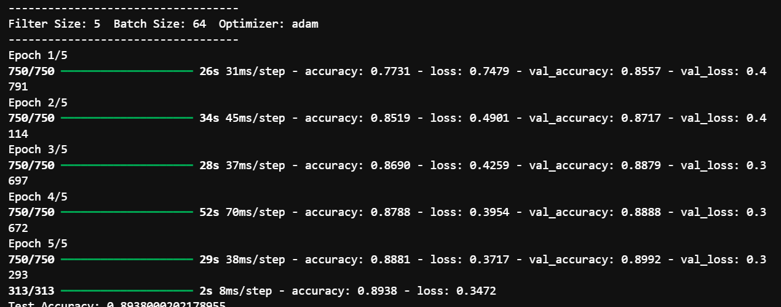
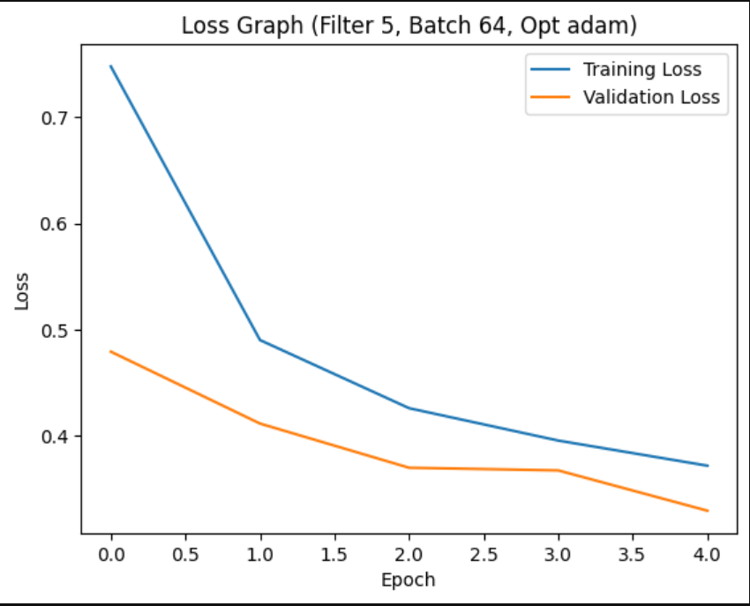

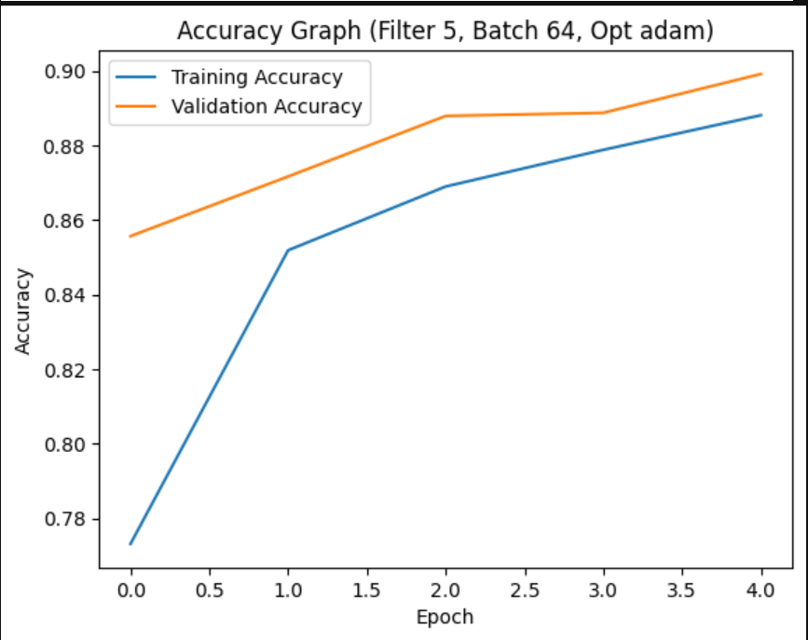

Comment
This code builds a CNN model to classify Fashion MNIST images.
First, the dataset is loaded and normalized. Then the images are reshaped so they can be used in a CNN model. A function is created to build the model with different filter sizes and optimizers. The program runs multiple experiments using different filter sizes, batch sizes, and optimizers. After training the model, the program evaluates test accuracy. Finally, it plots loss vs epoch and accuracy vs epoch graphs to analyze model performance.

